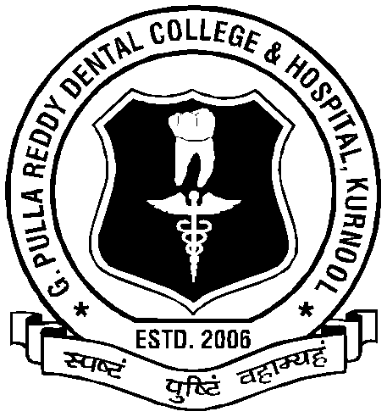
G. PULLA REDDY DENTAL COLLEGE AND HOSPITAL, KURNOOL.

It is hereby informed to all the allotted candidates for admission into the BDS course for the academic year 2023- 2024 under Management Quota (Cat-B & NRI) in the G.Pulla Reddy Dental College & Hospital that the following original certificates and 2 sets of Xerox copies of certificates are to be submitted at the time of admission.

S.NO | DETAILS OF CERTIFICATES
1. | Allotment Order Issued by the Dr.NTRUHS (Mandatory)
2. | Print out of online APPLICATION from duly signed by the candidate (Mandatory)
3. | Provisional verification form (Mandatory)
4. | NEET UG - 2023 – Admit Card & Score Card (Mandatory)
5. | SSC Marks Memo (Mandatory)
6. | Intermediate Marks Memo or Equivalent – (Grade Certificate not Accepted) (Mandatory)
7. | Study Certificates from 6th to Intermediate) (Mandatory)
8. | Transfer Certificate (Mandatory)
9. | Permanent Caste /Minority Certificate/PWD (to verify eligibility ,if secured less than General Category cut off marks) (If applicable)
10. | Aadhar Card (Mandatory)
11. | Candidate’s Latest passport size Photo -5 (Mandatory)
12. | NRI Documents: Declaration (Annexure-II) on White Paper signed by both the candidate and NRI along with evidential documents such as Green Card/Citizenship Card/Copy of NRI’s Bank Statement for last 6 months /Pass-port issued by the respective Country/ Latest Electricity Bill/Gas Bill /Water Bill in the name of NRI ( Visa / Driving license will not be accepted)

